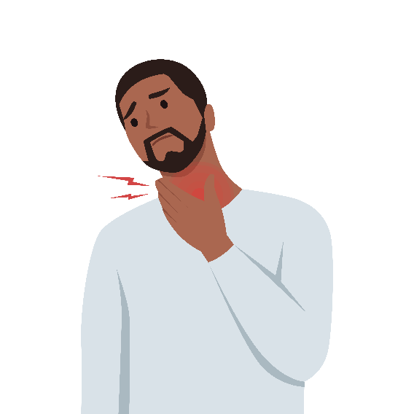
Pharyngitis – Patient Guide
What is pharyngitis?
- Pharyngitis, or a sore throat, is commonly caused by viruses and, less frequently, bacteria.
- Based on your clinical presentation, your healthcare provider decided if antibiotics may help you get better quicker.
What should I do to feel better?
- Acetaminophen (commonly called Tylenol®) can help with pain and fever and ibuprofen (commonly called Advil® or Motrin®) can help reduce pain and inflammation; store brands (e.g., CVS brand) are just as good as name brands (e.g., Tylenol®).
- Try warm tea with or without honey, warm soup, or throat sprays with benzocaine, cold or frozen desserts, or sucking on ice.
- For children over 5 years of age and adults, lozenges with menthol or benzocaine or hard candy may reduce throat pain.
- Consider gargling saltwater (which can be made by dissolving about ½ a teaspoon of salt in warm water).
- Hydration and rest always help.
- Avoid honey in children under 1 year of age because of the increased risk of botulism and to avoid any cough and cold medications in children under 6 years of age as these have been associated with overdoses.
- Herbal remedies, homeopathic therapies, and dietary supplements have not been shown to be effective.
When should I contact my healthcare provider?
- Fever and sore throat typically improve within 3 days; however, mononucleosis (mono) may take one month to resolve and fatigue may take several months to resolve. If diagnosed with mono, avoid contact sports for at least 3-6 weeks.
- If your healthcare provider was concerned about certain causes of bacterial pharyngitis, antibiotics may have been prescribed. Antibiotic treatment can potentially reduce symptoms of bacterial pharyngitis by about a day and other complications.
- If you have continued fevers after 3 days or worsening throat pain, you should seek an in-person visit.
- If you develop difficulty breathing or swallowing, confusion, or a bulging neck mass develops, you should go directly to an emergency department.

This document is intended to provide health-related information so that you may be better informed. It is not a substitute for your healthcare provider's medical advice and should not be relied upon for treatment for specific medical conditions.

Directions for Adding Your Logo to Your Document
If you chose to add a logo to this document, you can place it in the footer, below the article development content.
Steps:
- Open the footer section (either double click in the footer section of the document or go to the “Insert” tab → select the drop-down menu for “Footer”→ and click on “Edit Footer”).
- Make sure your cursor is below the bottom line (or wherever you want your logo).
- Go to the “Insert” tab.
- Click on “Pictures” from the “Insert” tab.
- A window will pop up so you can search your computer for the logo. Select your logo (.jpg or .png format) and click the insert button.
- Your logo will appear in your footer. If you are happy with the placement, skip step 7.
- ** If you want to move the logo image around, click on the logo → go to the
“Format” tab → click on the “Wrap Text” drop-down menu → and select “In front of text.” This formatting will allow you to move the logo freely around the screen.
- When you are satisfied with the placement of the logo, exit the footer section (either double click outside of the footer area or go to the “Design” tab → and click the “Close header and footer” button).

